# Flixverse: Movie & Series Recommendation Platform

**Done By:**

**Abdelrahman Yaser Abdelrahim**

**Hazem Saad Bayoumi**

**Katrean Adel Napil**

**Mostafa Ahmed Mohamed**

**1. Introduction**

* **Purpose**: Recommend movies/series based on genres, popularity, and user preferences.
* **Target Audience**: Movie enthusiasts seeking personalized recommendations.
* **Overview**:
  + Browse movies/series by genre or trending/popular categories.
  + Save favorites to "My List" and view detailed information.
  + User authentication for personalized experiences.

**2. Key Features**

* **Genre-Based Recommendations**: Action, Adventure, Comedy, etc.
* **Trending/Popular Sections**: Real-time updates via TMDB API.
* **My List**: Persistently saved using localStorage.
* **Details Page**: Cast info, trailers, and dynamic "Add to List" functionality.
* **Responsive UI**: Clean design with Bootstrap and custom styling.

**3. Technical Stack**

* **Frontend**: React, React Router, Bootstrap, Axios.
* **State Management**: React Hooks (useState, useEffect), localStorage.
* **API Integration**: TMDB API for movie data and trailers.

|  |  |
| --- | --- |
| **Member** | **Responsibilities** |
| Abdelrahman Yaser | App.jsx, Home.jsx, Navbar.jsx, Login/Register, DetailsPage.jsx, Core UI Logic. |
| Hazem Saad Bayoumi | Movies.jsx, MovieFetcher.jsx: Movie grid and API data handling. |
| Katrean Adel Napil | UserList.jsx: My List display, removal functionality. |
| Mostafa Ahmed Mohamed | PopularFetcher.jsx, Trending.jsx: Fetching and displaying trending content. |

**4. Team Roles**

**5. Setup Instructions**

git clone [your-repo-url]

npm install

npm run dev

**Note**: The TMDB API key is pre-configured in the code.

**6. Screenshots:**

**Home Page:**

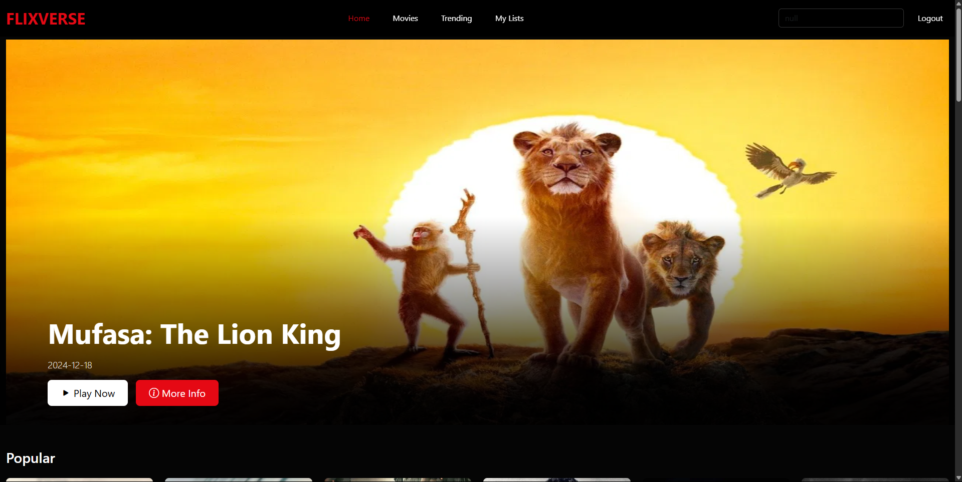

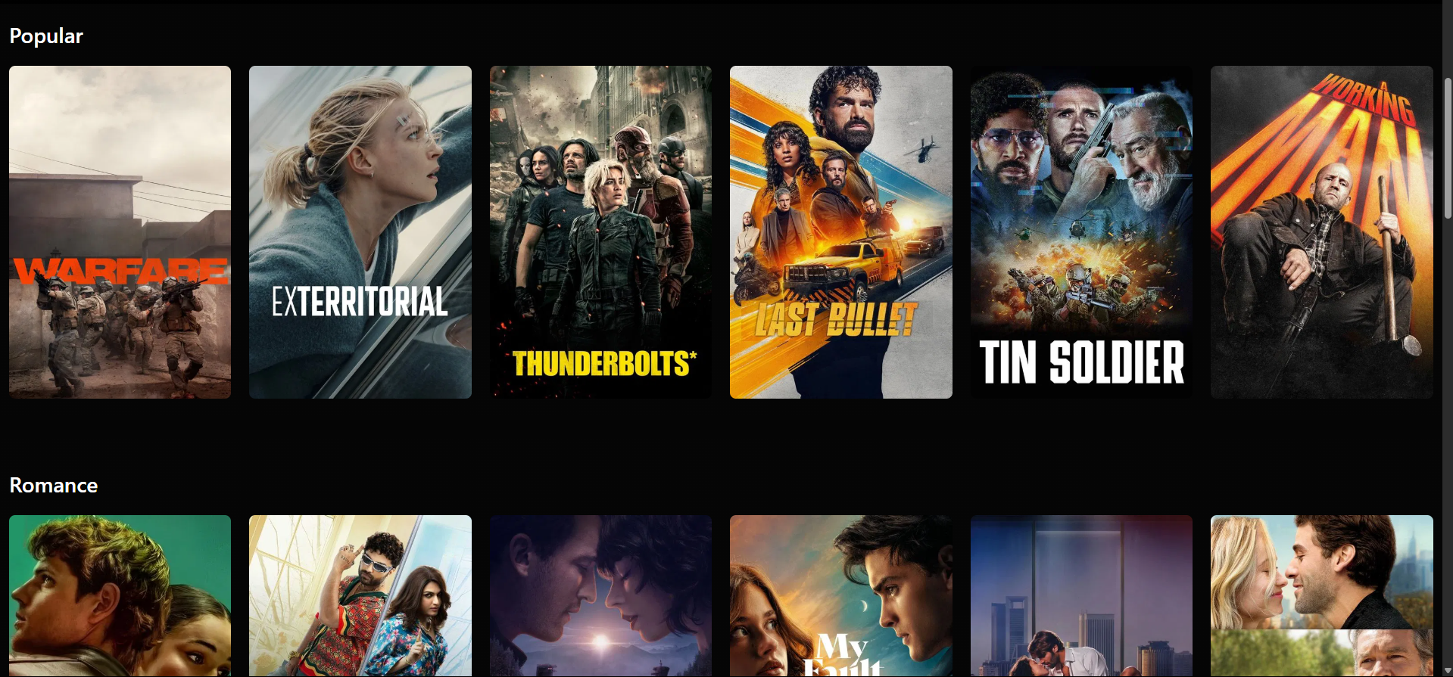

**Movies Page:**

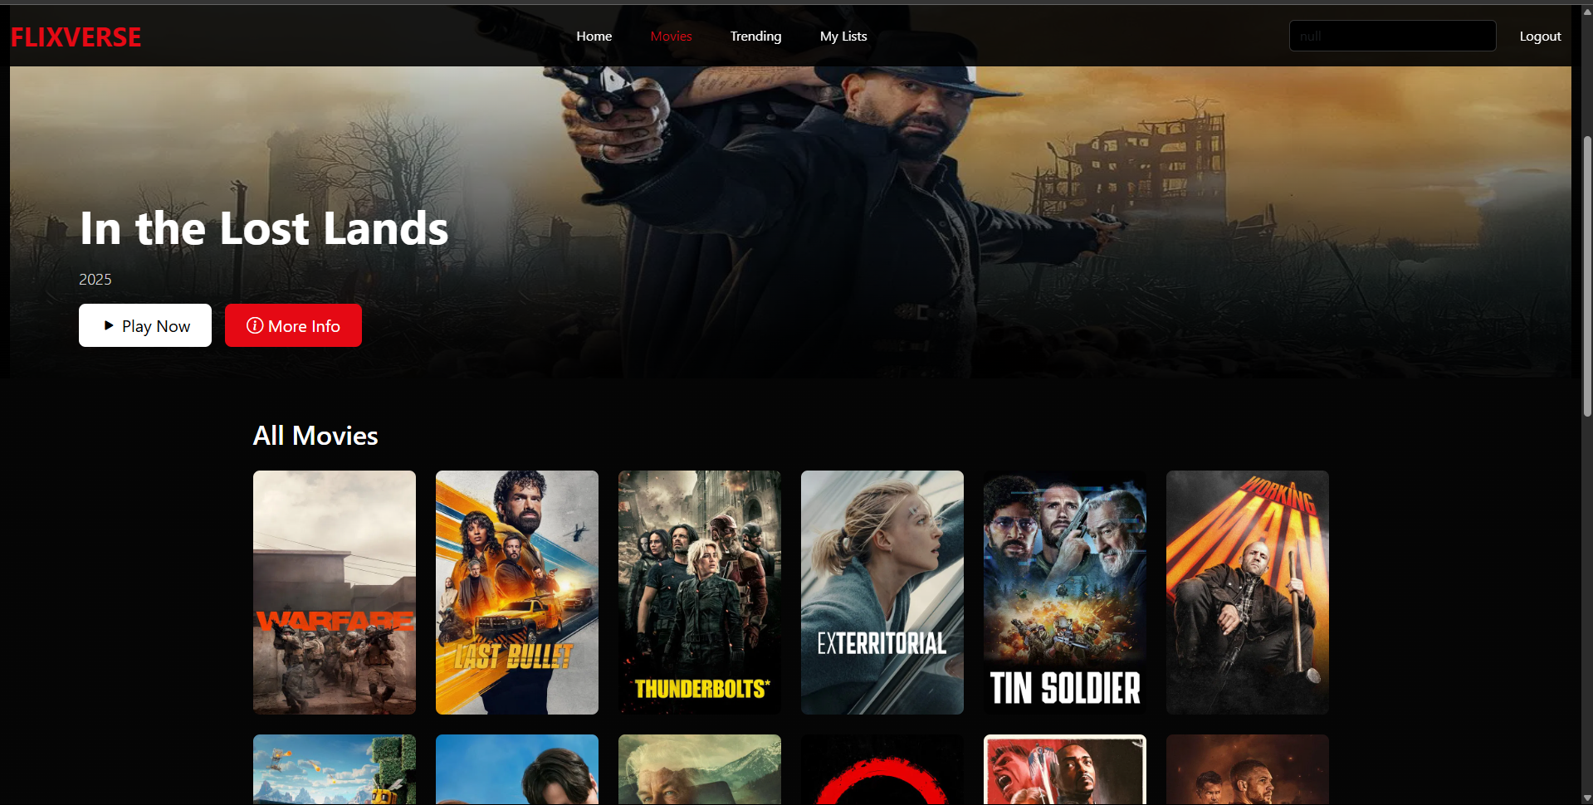

**Trending:**

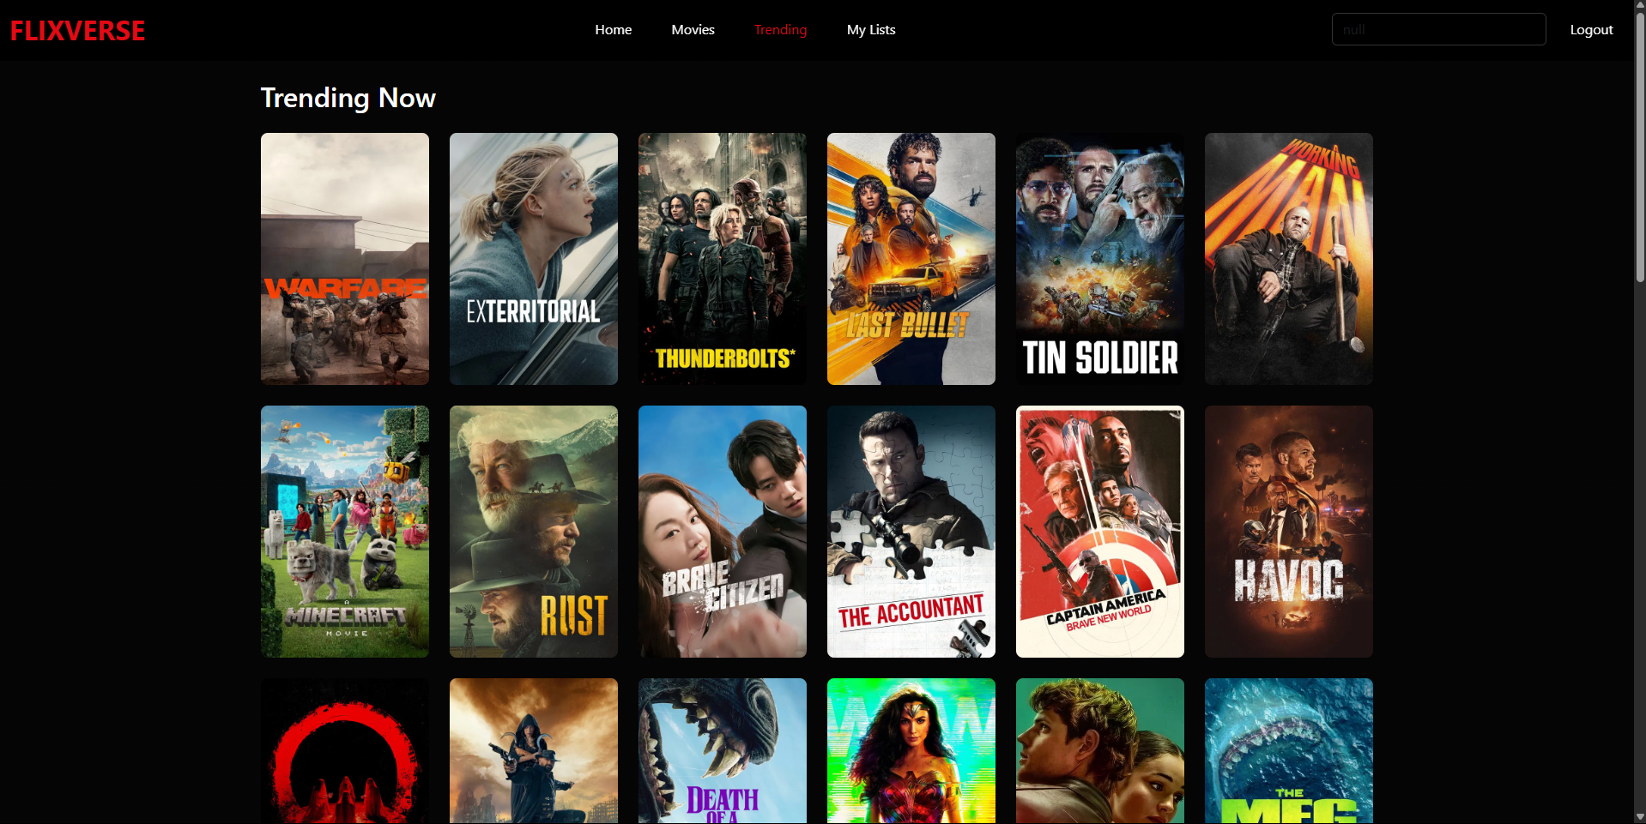

**My List:**

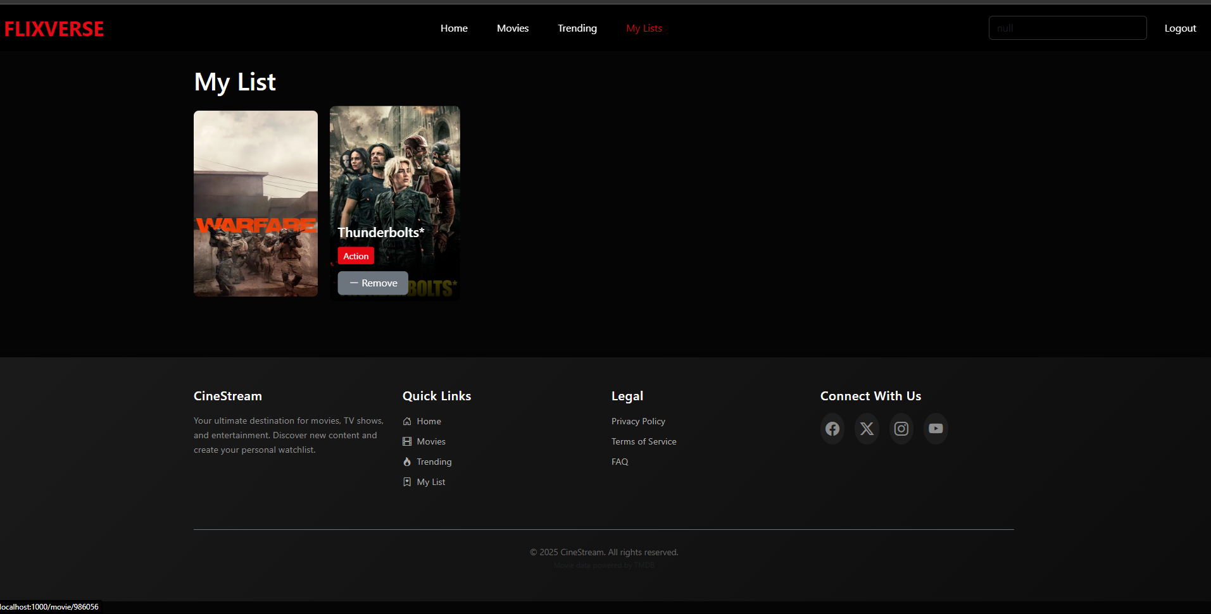

**Details Page:**

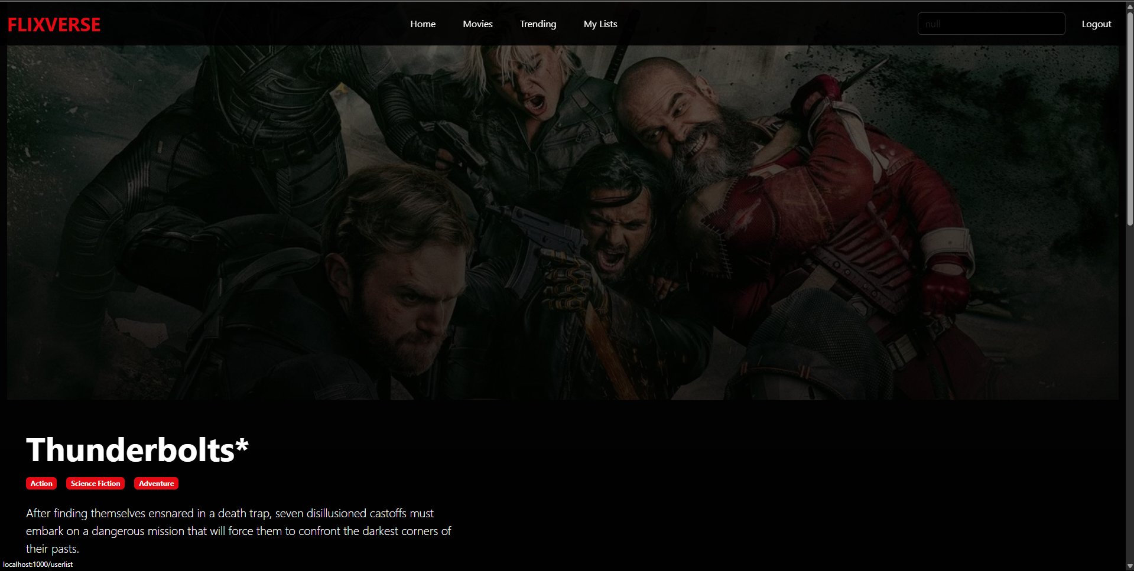

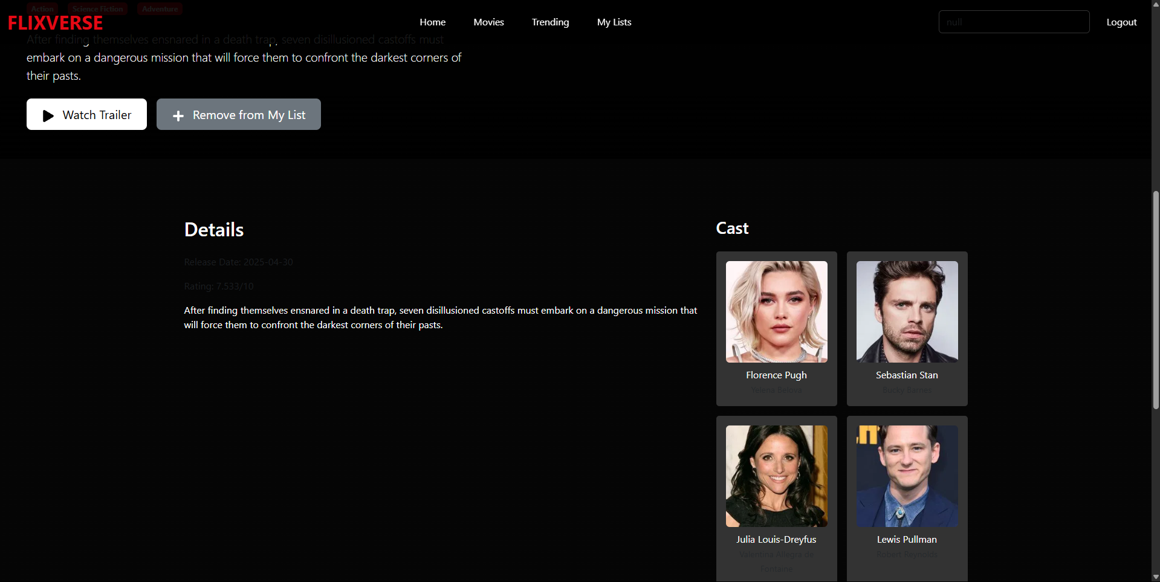

**7. Challenges & Solutions**

* **API Rate Limits: Cached data to minimize requests.**
* **State Persistence: Used localStorage for "My List" across sessions.**
* **Dynamic Routing: React Router for details pages (/:mediaType/:id).**